ch
1.
A Project Report On


Employee Management System

Submitted in partial fulfillment of the requirement for the award of the degree
Bachelor of Computer Application (BCA)

Academic Year 2023 – 24
(Divy Palejiya) 92200527240
(Divyesh Gangah) 92200527243
(Aryan Ponkiya) 92200527253

Internal Guide
(Prof. Shivaniba Bhadoriya)



Rajkot-Morbi Road, At & PO : Gauridad, Rajkot 360 003. Gujarat. India.

Faculty of Computer Applications (FCA)

This is to certify that the project work entitled
Employee Management
submitted in partial fulfillment of the requirement for the award of the degree of
Bachelor of Computer Application
of the
Marwadi University
is a result of the bonafide work carried out by
Divy Palejiya(92200527240) Divyesh Gangah(92200527243) Aryan Ponkiya(92200527253)

during the academic year 2023-24

Shivaniba Bhadoriya Sunil Bajeja Shridharan Sir

Faculty Guide |  | HOD |  | Dean

DECLARATION

We hereby declare that this project work entitled Employee Management System is a record done by me.
I also declare that the matter embodied in this project is genuine work done by me and has not been submitted whether to this University or to any other University / Institute for the fulfillment of the requirement of any course of study.

Place : Marwadi University – Rajkot
Date : 10/4/2024

Divy Palejiya (92200527240) Signature : Divy

Divyesh Gangah (92200527243) Signature: Divyesh Aryan Ponkiya (92200527253) Signature: Aryan

CONTENTS
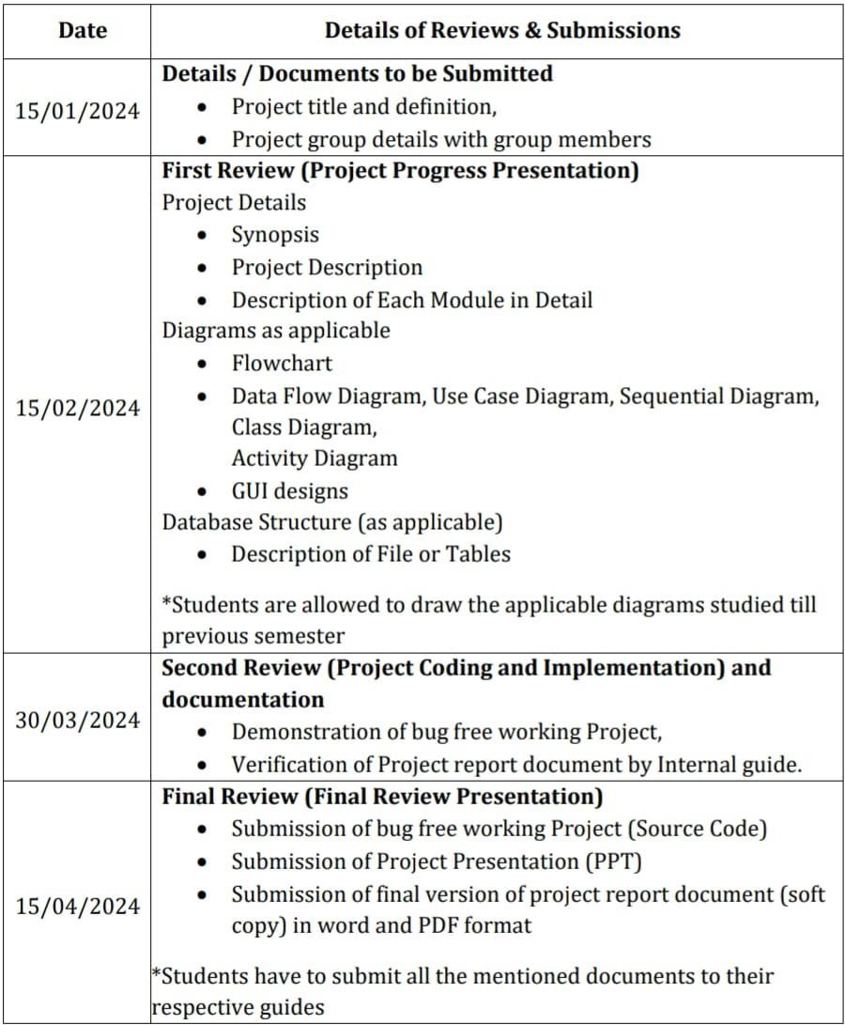

PROJECT DETAILS

  - SYNOPSIS

The Employee management system is a software that shows you all information about entered employee detail. Our project aims to create an interactive and informative digital employee management system that stores all entered employee information. We save employee’s ID, Name, Department, Joining Date, Gender, Salary and many other things about employee. And after that you can Remove/Delete the this that you want.

PROJECT DISCRIPTION

The Employee management system is designed to get all information about entered employee detail. It saves more employee than a simple employee system. It is useful to save all information about employee and make changes on it. Many companies can use this management system and manage their all employee. It saves employee’s ID, Name, Department, Joining Date, Gender, Salary and many other things about employee. And after that you can Remove/Delete the this that you want.

1.2 DESCRIPTION OF MODUEL

- Main Method (main method):

  - Responsible for initializing the database (Database.dbInit()) before launching the Swing application.

  - Launches the main window (Employee Management class).

- Employee Management Class:

  - Represents the main class for the Employee Management System.

  - Initializes the main JFrame and handles the overall organization of the GUI components.
- Initialization (initialize method):

  - Sets up the main JFrame for the application, including its title, size, and layout.

  - Creates and configures UI components such as text fields, labels, buttons, and the JTable.
- Input Panel:

  - Contains input fields for entering employee details (ID, name, department, etc.).

  - Provides buttons for inserting and updating employee records.

  - Displays a title at the top using a JTextArea.

DIAGRAM AS APPLICABLE

ALGORITHM AND FLOWCHART
- Algorithm

Step 1: Start.

↓

Step 2: Enter employee info that you want to find (Otherwise go to step).
↓

Step 3: Print the employee detail

↓

Step 4: Get all information about employee.

↓

Step 5: End

FLOWCHART













Start
Find the employee
information that you want
End
Print the all employee details
that you want
Enter employee Detail




  - DATAFLOW DIAGRAM

Employee Name

Employee ID

Add Employee

Employee Managemen t System

Login

Add Salary

Employee Account

USECASE DIAGRAM









Employee name

Add employee

Add salary

Employee account

Login

Employee ID

SEQUENTIAL DIAGRAM

Employee
System Manager

Admin

Provide Details
Provide Details

e Account
Creat

Log In

Authenicate

Request to modify/remove account
Forward Request

Update/Delete Account

CLASS DIAGRAM
+ AddEntries ()
+ UpdateEntries()
+ DeleteEntries()
- AdminID : String
- AdminName : String
Admin
Employee Account
- AccountID : String
- Type : String
- AccountNo : String
+ Update()

Add Employee
- EmpID : String
- EmpName : String
- ContactNo : String
- Email : String
+ Insert()
+Update()

Login
- EmpID : String
- Password : String
+ Access()
+ Varification()

Employee
- EmpID : String
- EmpName : String
- ContactNo : String
- Email : String
+ ViewSalSheet() ViewAttendance()

Salary
- EmpID : String
- TotalAmount : String
- SalaryDeducts : double
- SalaryAdvance : Double
+ GetSalInfo()
+ GrossSal()

  - ACTIVITY DIAGRAM

EMPLOYEE

Login

Verify

Account
Apply Leave
Reports
Change Password
Leave Report
Salary
Leave

LogOut

- Entity Relationship Diagram

Username
ID
Email

Has
Login
Employee

Name

Password
Phone

OUTPUT OF THE PROGRAM
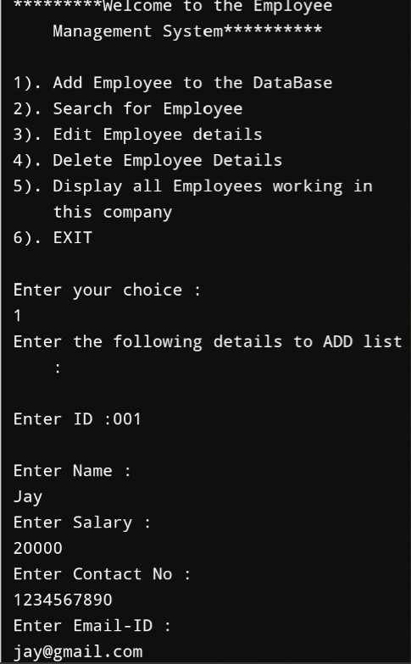

- TESTCASES FOR THE MINI PROJECT

Select your choice
Here you can choose 6 different type of choice.

Choice one
Input – “1”
Output – You can add the new employee details in the management system.

Enter ID
Input – “ID”
Output – Here you can add id no. of an employee.

Enter Name
Input – “Name”
Output – Here you can save the employee full name.

Enter Salary
Input – “Salary in Rupees”
Output – Here you can add employee salary in Rupees.

Enter Contact No.
Input – “Contact No”
Output – Here you can add and save employee contact no.

Enter email-ID
Input – “Enter email-id”
Output – Here you can add employee’s email-id.

Choice two
Here you can search for employee that work in your company.

Choice two
Input – “Any employee’s ID.
Output – If you write any employee’s id, this project show you that employee’s all details.

Choice three
Here you can change any employee’s ID, Name, Salary, Contact no, Email ID.

Choice four
Here you can remove any employee’s details.

Choice five
Input – “Choice five”
Output – It will show you all the employee’s details that work in your company.

Choice six
Input – “Choice six”
Output – If you choose choice six, You close your work/this project.

LEARNING DURING PROJECT

  - Choose a simple project
    - Select a small project idea is that aligns with your current level of Java language knowledge. Example could include a Employee Management System.

- Study Relevant Concepts
  - As you encounter new concepts and functions, refer to Java language documentation, textbooks, or online tutorials to understand them batter. Topics like variables, loops and functions are essential.

- Write code incrementally
  - Start with the basics and build your project incrementally. Test each part as you go to ensure it works before moving on to the next.

- Debugging
  - Debugging is a important part of the learning process. When you encounter errors, use debugging tools and print statements to identify and fix them.

- Share and Discuss
  - Share your project with others, whether it’s friends, mentors, or online communities. Discussing your code can lead to valuable insights and suggestions for improvement.

BIBLIOGRAPHY

  - Online Refrances
    - “Javatutorial” → W3Schools, Javapoint
    - YouTube → ‘Codewithherry’

THANK YOU
(Specially, To our project Guide)

